Writing Systems Editor Documentation

Writing Systems Editor Documentation

Table of Contents
About This Document 1
Who Should Read This 1
What You Will Learn 1
Document Conventions 1
Installing the Writing Systems Editor 2
Downloading WS Edit 2
Running the Installer 2
Setting up a Writing System 4
Adding a Writing System 4
Editing a Writing System 4
About 4
Spelling 5
Fonts 5
Keyboards 6
Sorting 7
Reference 8
WS Edit Features 8
Editing Tabs 8

About This Document

Who Should Read This
This document is intended for people beginning to use the Writing Systems Editor (WS Edit) tool. It will explain in basic terms how to get started with, and use, WS Edit.

What You Will Learn
This document will show you step by step how to download, install and use WS Edit. It is also useful for a reference if you need to quickly find information about a specific part of WS Edit.

Document Conventions
In this document you will find two basic conventions that denote importance. There are:

Info signs, which are for clarification or expanding on the topic;

Lightbulbs, which indicate tips and extra information;

Also, if you come across a set of words in italics, separated by a series of | marks, this indicates a series of steps you need to go through. For instance, My Documents | My Music means you need to open My Documents and then open the My Music folder.

Installing the Writing Systems Editor

Downloading WS Edit
Before you can install the Writing Systems Editor tool, you will need to download the installer. You can find the installer at http://palaso.org/install/wsedit. On this page, click the most recent file to download it.
To find the right file, look for a name like 'WSEditSetup_0.1.8.exe' that has a size of roughly1.0 M.

Running the Installer
Once the file has finished downloading, double-click on the icon to start the setup. There will be a window popping up asking you to press Next. Once you press Next, the installer will complete the installation without requiring any further input.
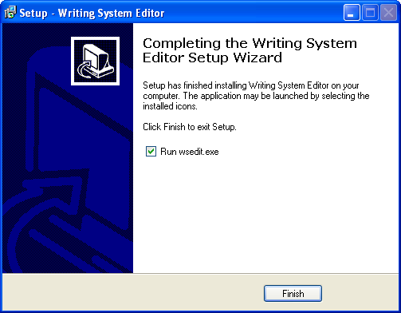
When you get to the above screen, you can either leave the check box checked to open the Writing Systems Editor after you exit the setup, or uncheck the box to only quit the setup. Once you've decided, press Finish to exit the installer.
Now that WS Edit is installed on your computer, you can access it through Start Menu | Programs | WSEdit.
If the program Solid is already installed on your computer, you can find the WS Edit program under Menu | Programs | Solid.
Once you've finished the installer, you can open WS Edit to begin making new writing systems.

Setting up a Writing System

Adding a Writing System
The first step to making a writing system is to create a new writing system in the pane on the left of the screen. WS Edit will automatically have a template writing system in place, named 'New', but if you want to add additional writing systems, you will need to use the Add button at the bottom of the WS Edit window, as shown below.
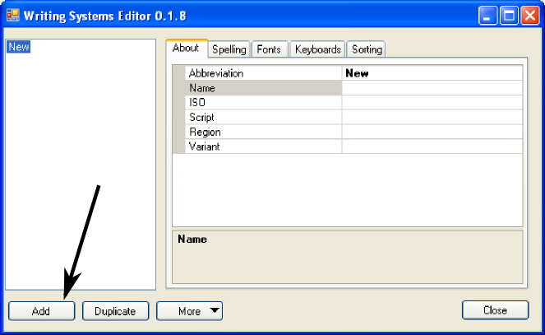
You can also use the Duplicate button to make more writing systems. Pressing duplicate will create an identical clone of the writing system you are selecting.
Once you have a writing system created, you can begin editing that system, using the tabs shown on the right of the WS Edit window.

Editing a Writing System
To edit a writing system you will need to use all five tabs, starting with the About tab.

About
In this tab, you can click on any of the fields and WS Edit will give a brief summary in the lower right hand pane.
Start by choosing the writing system's abbreviation – what it will appear as in the programs you use.
This is sometimes the same as the writing system's ISO code, but it doesn't necessarily have to be. Use whatever is most comfortable for you.
Next choose the name of the language the writing system will be used for. Then select the writing system's ISO code. This is a specific character code universally used to identify languages. If you don't know the ISO code of the writing system you are making, press the ellipses button on the ISO field to choose from a list of languages.
The last three lines, the Script, Region and Variant lines, you only need to use if your writing system is of a language with different variants. For instance, you could use the Script line to differentiate between separate Chinese scripts, or the Region line to differentiate between American English and Australian English.

Spelling
This tab only has the line 'Spell Checking ID'. Enter an Open Office spell checker into the box in order to have your new writing system be automatically spell checked.

Fonts
The Fonts tab has three different panes you can use to set up your writing system's font.
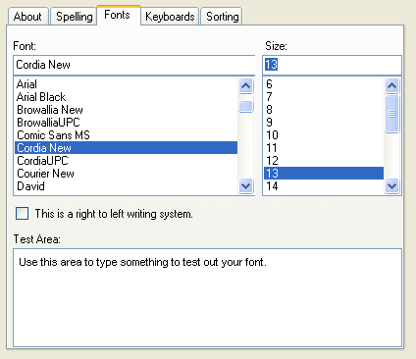
The pane labeled 'Font:', you can use to change the actual font your system will display in. The 'Size:' pane you can use to grow or shrink your font, and the 'Test Area:' pane is for typing in to see how your selected font works with your other keyboard or language settings.
Certain fonts work well with certain languages, but barely show up with other languages. For a given language, you will need to test to make sure the font you are using displays clearly.
You can also choose whether your language reads from left to right or right to left by checking the check box in the middle of the screen.

Keyboards
In the Keyboards tab you choose what actual language your writing system will display in. You can only choose languages already set up on your computer.
On Windows you can tell what languages you have on your computer by the language bar on the bottom right side of your screen or by clicking on the Keyman icon. You may need to restart WS Edit after installing or updating your keyboards.
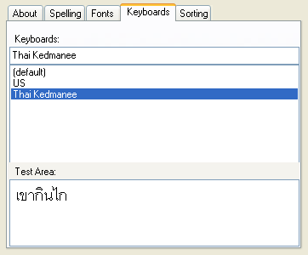
Use the test area to see how your new language displays. If it isn't clear, you may need to go back to the Fonts tab and choose a different font.

Sorting
In this tab you can choose what order the alphabet will sort in. WS Edit will automatically set your alphabet to a standard sorting order, but if the language you are working with has a peculiar order of letters, you can use the Sorting tab to change the writing system's sort order.
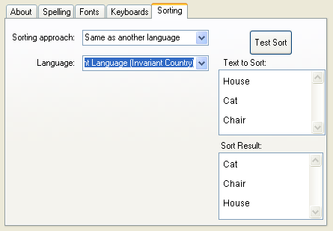
You can choose what template sorting approach WS Edit will use by the drop down menu 'Sorting approach:'. There are two custom sort orders you can use and modify to change your language's sorting. Or, if your language has no abnormalities, you can find your language in the 'Language:' drop down menu and select it.
Also, you can make sure your writing system is sorting correctly by typing words in the top pane and pressing Test Sort. The Sort Result shows how your alphabet is organized.
By using all five tabs to customize your writing system, you can tailor your new writing system to your needs. Or you can take an old writing system and make fixes and changes with WS Edit to keep it updated.

Reference

WS Edit Features
As well as being able to add new writing systems, duplicate existing ones, and edit them with the five tabs, WS Edit has more features in the 'More' drop down menu on the bottom of the window.
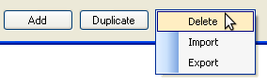
The Delete function deletes whatever writing system you select. The Import function can bring in any writing systems on your computer, provided you know where to find them. The Export function saves your selected writing system for later use.
The writing systems that you save or import will be either in the LDML format or the XML format.

Editing Tabs
See the guide 'Setting up a Writing System' for specific information about each of the five tabs in the Writing Systems Editor tool.

